VPC Peering & Cross-VPC Connectivity
By Haroon Zaman | November 2025

Introduction
In this project, I learned how to connect two separate VPCs using VPC Peering. Each VPC is normally isolated and cannot communicate with other networks unless we explicitly allow it. By setting up VPC peering, I enabled private, secure communication between two VPCs without sending any data over the public internet.
This project helped me understand multi-VPC architectures, private routing, and how cloud resources communicate across isolated networks safely.
In this project, I completed the following tasks:
- Set up multiple VPCs – I created two different VPCs, each with its own CIDR range, subnets, route tables, and resources.
- Created a VPC Peering connection – I established a private network link between both VPCs so they could communicate.
- Tested VPC peering with connectivity checks – I verified communication using private IP addresses, confirming that traffic stayed inside AWS’s private backbone network.
VPC peering ensures that data travels privately, directly between VPCs.
Without peering, traffic would need to go through the public internet, which is less secure and not ideal for internal workloads.
Creating the First VPC
- First, I created a new VPC using the VPC and More option.
- I named this VPC My_Network_VPC1 so it’s easy to identify later.
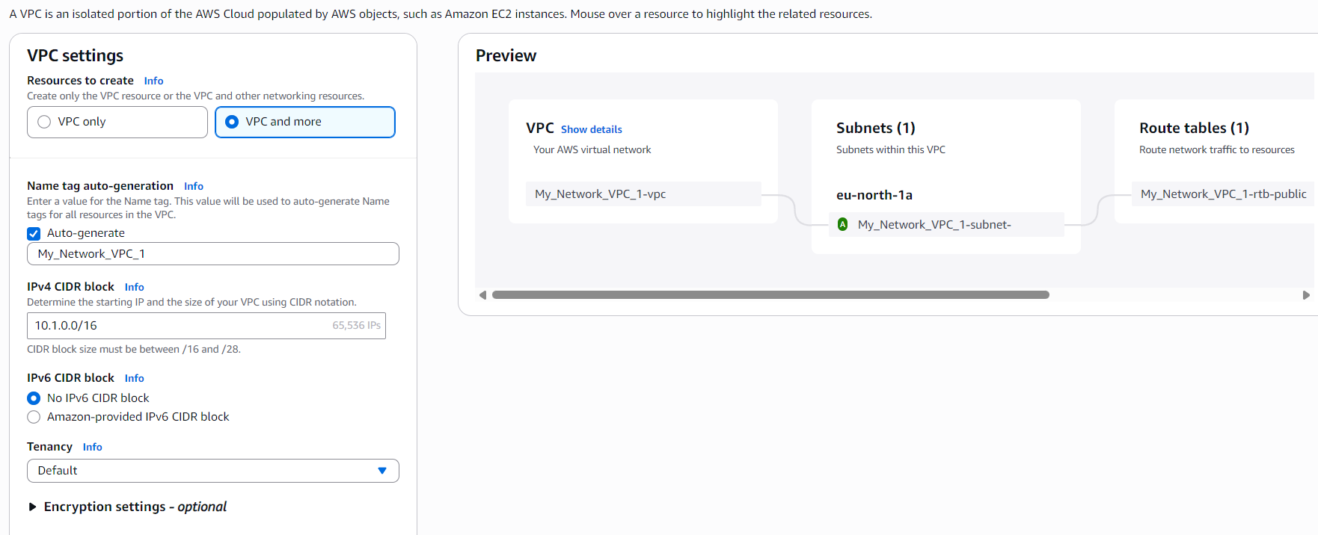
- I declared the IPv4 CIDR block as 10.1.0.0/16, giving the VPC plenty of private IP space.
- I chose No IPv6, since this project focuses only on IPv4 connectivity.
- I set Tenancy to Default, as I did not need dedicated hardware for this setup.
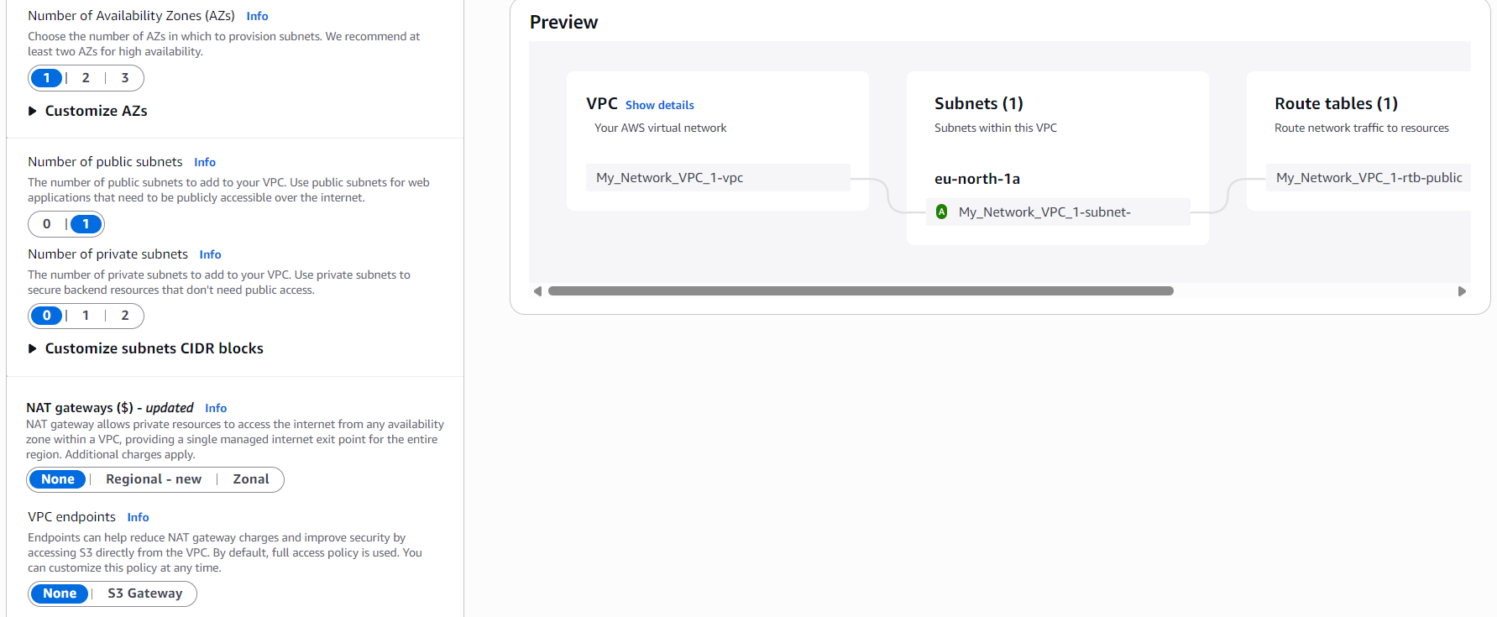
- I selected 1 Availability Zone with one public subnet and no private subnet.
This is because this VPC will only be used for testing VPC peering, and I only needed a simple network structure with one public subnet.
- I selected No NAT Gateway.
NAT gateways are only needed when private subnets require outbound internet access. Since I did not create a private subnet and didn’t need internet access from inside the VPC, a NAT gateway wasn’t necessary.
- I also selected No VPC Endpoints.
VPC endpoints are used when you want to privately connect your VPC to AWS services like S3 or DynamoDB.
Since this project focuses only on VPC-to-VPC connectivity, and not on private access to AWS services, VPC endpoints were not required.
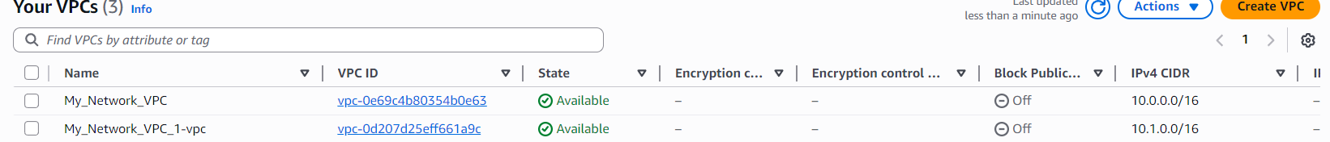
- After I created both VPCs, I verified their CIDR ranges:
  - My_Network_VPC1: 10.1.0.0/16
  - My_Network_VPC: 10.0.0.0/16
- Each VPC had its own unique CIDR block, which is required for VPC peering.
VPCs cannot overlap in IP ranges if they need to communicate, so using different CIDR blocks made them compatible for peering.
- With both VPCs fully created and isolated from each other, it was now time to connect them using a VPC peering connection so they could communicate privately.

Creating the VPC Peering Connection
- Next, I went to Peering Connections from the left-side panel of the VPC console.
- I clicked on Create Peering Connection to start setting up the link between my two VPCs.
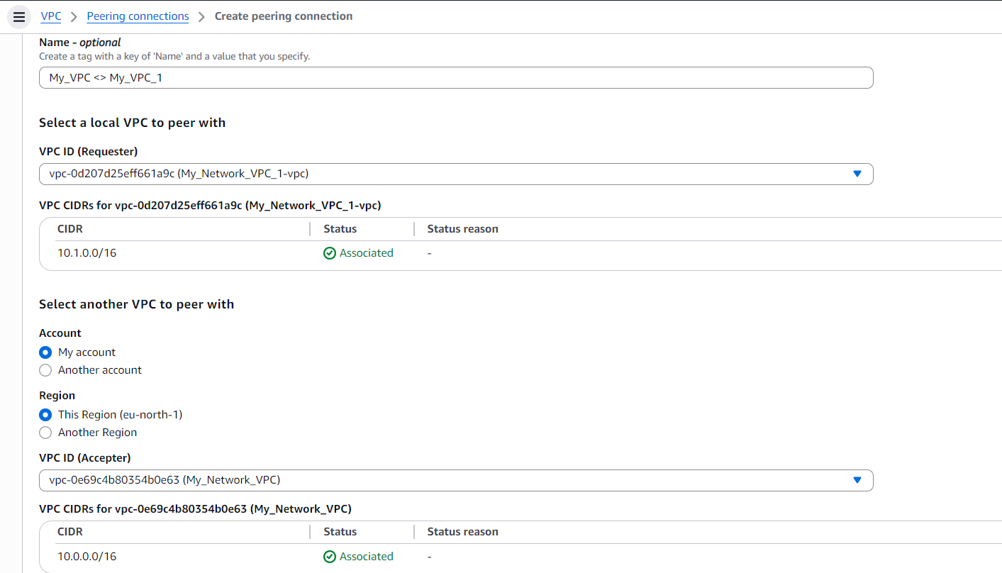
- I named the peering connection My_VPC <> My_VPC1 so it was easy to recognize.
- First, I selected the Requestor VPC, which was My_Network_VPC1.
The requestor is simply the VPC that initiates the peering request.
- Then I selected the Acceptor VPC, which was My_Network_VPC.
The acceptor is the VPC that receives the request and must approve it.
- In the acceptor settings, I noticed AWS allows peering with other accounts and even other regions, making cross-account or cross-region peering possible.
But for this project, I selected my second VPC in the same region.
- After selecting both sides, I clicked Create Peering Connection to create the request.
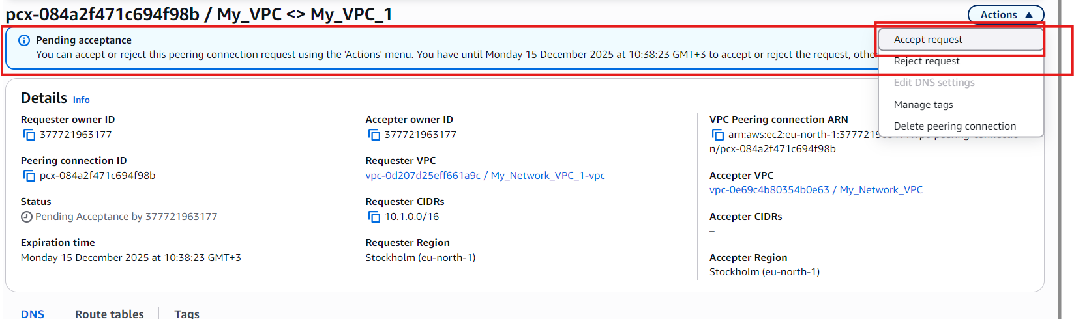
Accepting the Peering Request
- After creating the peering connection, it was still in the Pending Acceptance state.
- Because both VPCs are in the same AWS account, I had full permission to approve the request myself.
- I selected the peering connection, went to Actions, and clicked Accept Request.
- Once accepted, the peering status changed to Active, meaning both VPCs were now allowed to communicate privately.
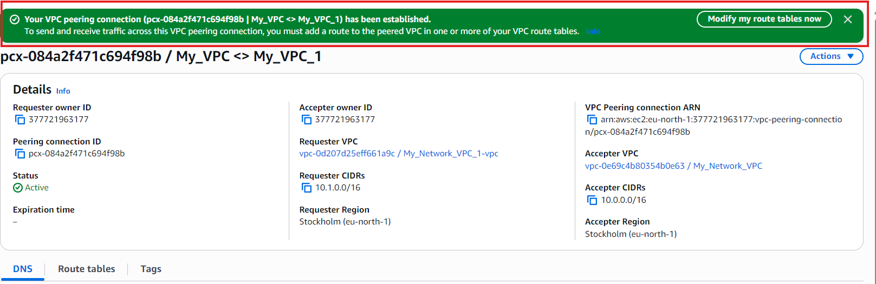
Updating Route Tables for VPC Peering
- After activating the peering connection, the two VPCs were allowed to communicate — but they still could not send traffic to each other yet.
- This is because VPC peering does NOT automatically update route tables. Each VPC must be told where to send traffic intended for the other VPC.
- In simple words:
Peering creates the link.
Route tables decide the path.
Without adding routes, the instances inside the VPCs do not know how to reach each other’s IP ranges.
- To fix this, I opened Route Tables in the VPC console and selected the route table for my first VPC.
- Then I clicked Edit Routes to add a new entry pointing to the peering connection.
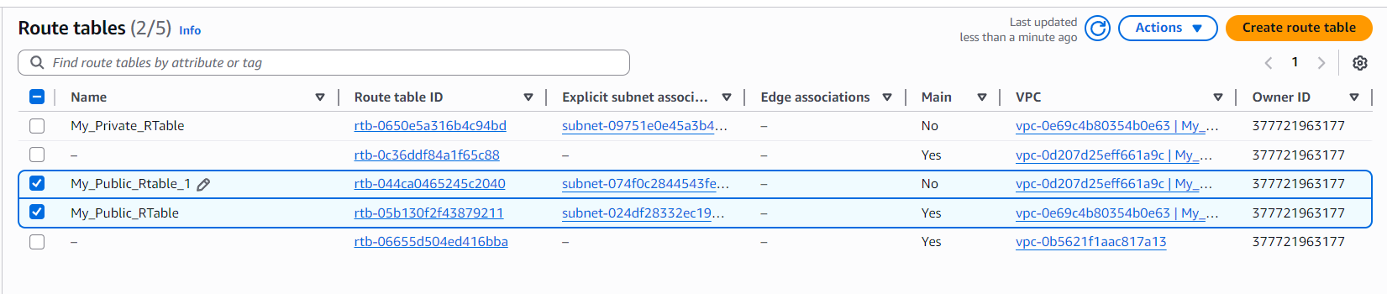
Setting Routes for Cross-VPC Communication
- Each route table belongs to a different VPC, which means they control traffic inside their own VPC only.
- To make both VPCs talk to each other, I had to manually create a path in each route table that points to the peering connection.
- Without these routes, even though the peering link exists, the instances won’t know how to reach the other VPC’s IP range.
- So I opened the route table for the first VPC and prepared to add a route that sends traffic to the other VPC’s CIDR block through the peering connection.
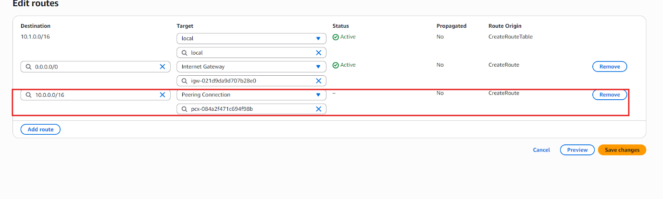
Adding Routes to Both VPCs
- My My_Public_RTable1 belonged to My_Network_VPC1, which uses the CIDR block 10.1.0.0/16.
- My My_Public_RTable belonged to My_Network_VPC, which uses the CIDR block 10.0.0.0/16.
- I opened My_Public_RTable1 first and added a new route.
  - Destination: 10.0.0.0/16 (the CIDR block of the second VPC)
  - Target: the VPC peering connection
This tells VPC1 that any traffic meant for 10.0.0.0/16 should be sent through the peering link.
- Then I opened My_Public_RTable and did the exact same thing in reverse.
  - Destination: 10.1.0.0/16 (the CIDR block of the first VPC)
  - Target: the same peering connection
This allows VPC2 to send traffic back to VPC1.
- After adding these routes, both VPCs now had a two-way private path for communication through the peering connection.
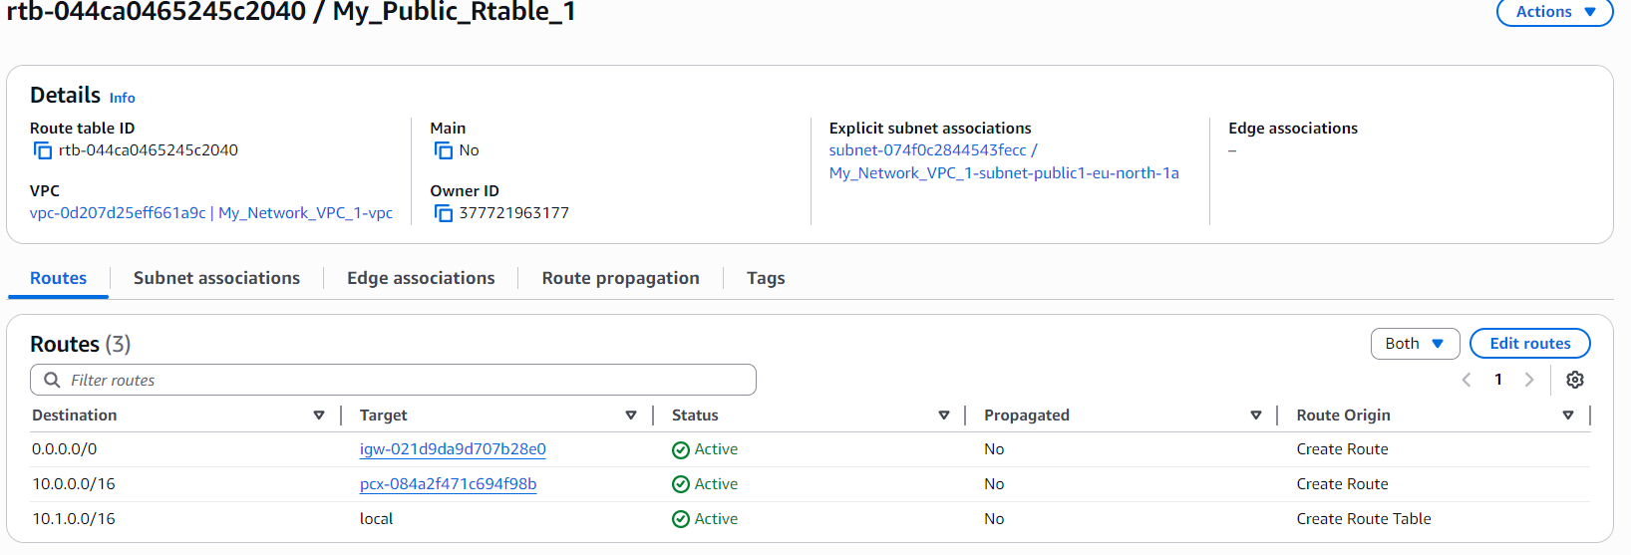
Why We Must Add the Other VPC’s CIDR Block (Even Though the Route Table Already Has 0.0.0.0/0)
- Even though the public route table already had the route 0.0.0.0/0 → Internet Gateway, that only sends traffic to the internet, not to another VPC.
- The CIDR block 0.0.0.0/0 means “send all unknown traffic to the internet,” but the other VPC’s IP range (10.x.x.x) is not on the public internet.
It exists inside AWS’s private network, not outside.
- Because of this, the route table needs a specific rule telling it:
“If the destination is the other VPC’s private CIDR block, send it through the peering connection, not the Internet Gateway.”
- Without adding the other VPC’s CIDR block, the instance would try to send that traffic to the Internet Gateway, which cannot reach private AWS networks.
The traffic would simply get lost.
- By adding the correct CIDR block and pointing it to the peering connection, we are telling AWS:
“This traffic is meant for another private network — send it through the private link, not the internet.”
- This is why every VPC peering setup requires explicit route entries for both VPCs, even when using public route tables.

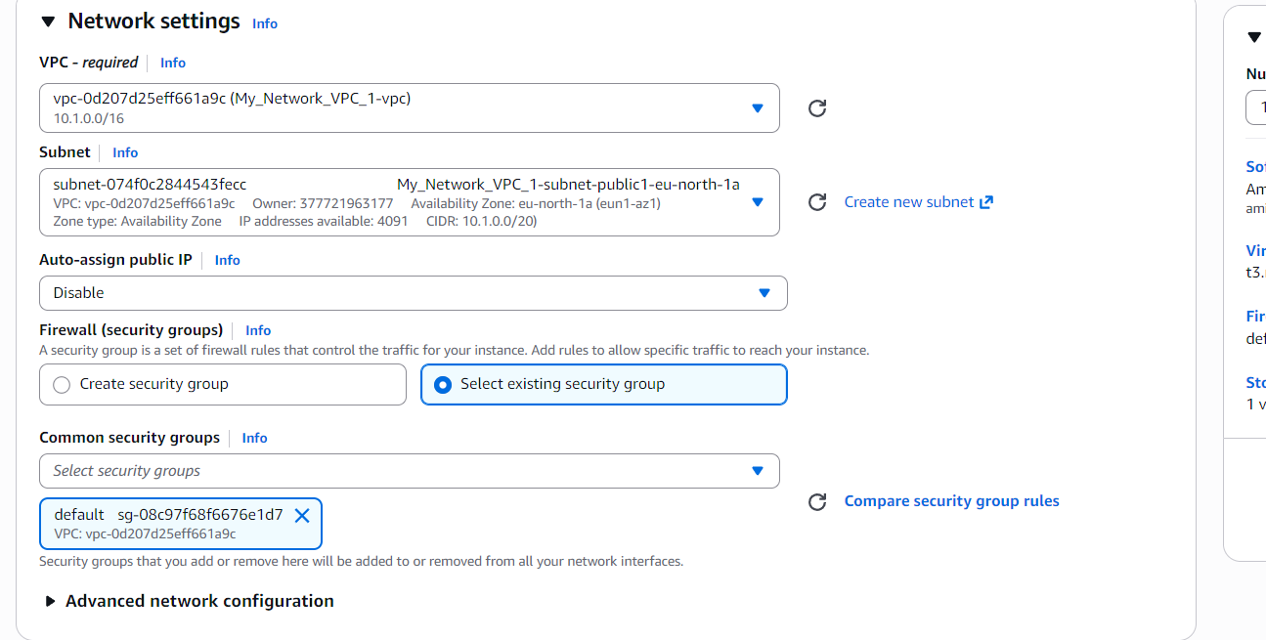
Creating EC2 Instances in Both VPCs for Peering Tests
- To test VPC peering, I needed to run an EC2 instance inside each VPC.
This allows me to send traffic from one VPC to the other using private IP addresses.
- First, I created an EC2 instance and named it My_EC2_1.
  - I selected My_Network_VPC1 as the VPC.
  - I chose the public subnet of that VPC.
  - I disabled Auto-assign Public IP, because for peering tests we only want private-to-private communication.
  - For the security group, I selected the default SG that was automatically created when the VPC was created.
- Then I created another EC2 instance in the second VPC and named it My_EC2.
  - I placed it inside My_Network_VPC.
  - I used the public subnet of this VPC as well.
  - I applied the same settings: no public IP and the default Security Group of its VPC.
- At this point, each VPC had its own EC2 instance, ready to test cross-VPC communication through the peering connection.
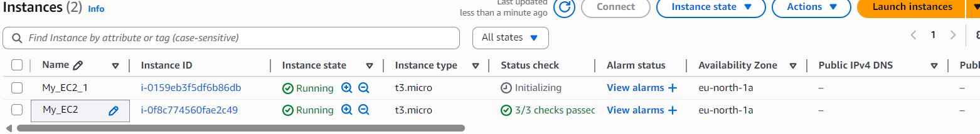
Connection Error – No Public IP
- After both instances were created, I selected one of them and tried to connect using the AWS Connect button.
- However, I received an error saying that the instance has no public IP address.

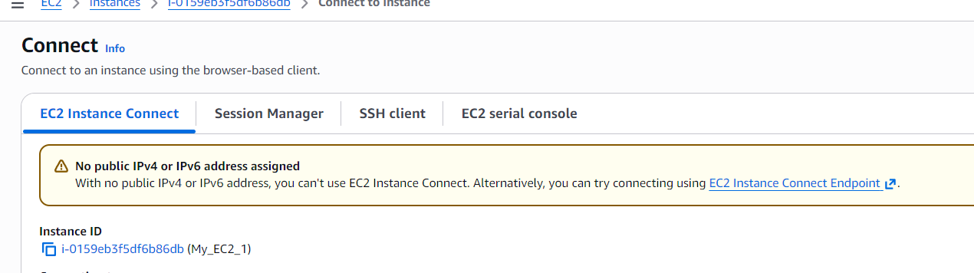
- The reason is simple:
The AWS browser-based EC2 Connect method requires a public IP so AWS can reach the instance over the internet.
Without a public IP, the instance cannot be accessed directly from the AWS console or the outside world.
- Since I purposely disabled Auto-assign Public IP on both instances (because peering tests use only private IPs), the console connection method could not work.

What Are Elastic IPs?
- Elastic IPs are static IPv4 addresses that AWS allocates to your account.
- “Static” means the IP stays the same, unlike the dynamic public IPs that EC2 instances normally get.
- When an EC2 instance restarts, its normal public IP changes — but an Elastic IP does not.
- Having an Elastic IP is like having a permanent address, instead of moving to a new house every time the instance restarts.

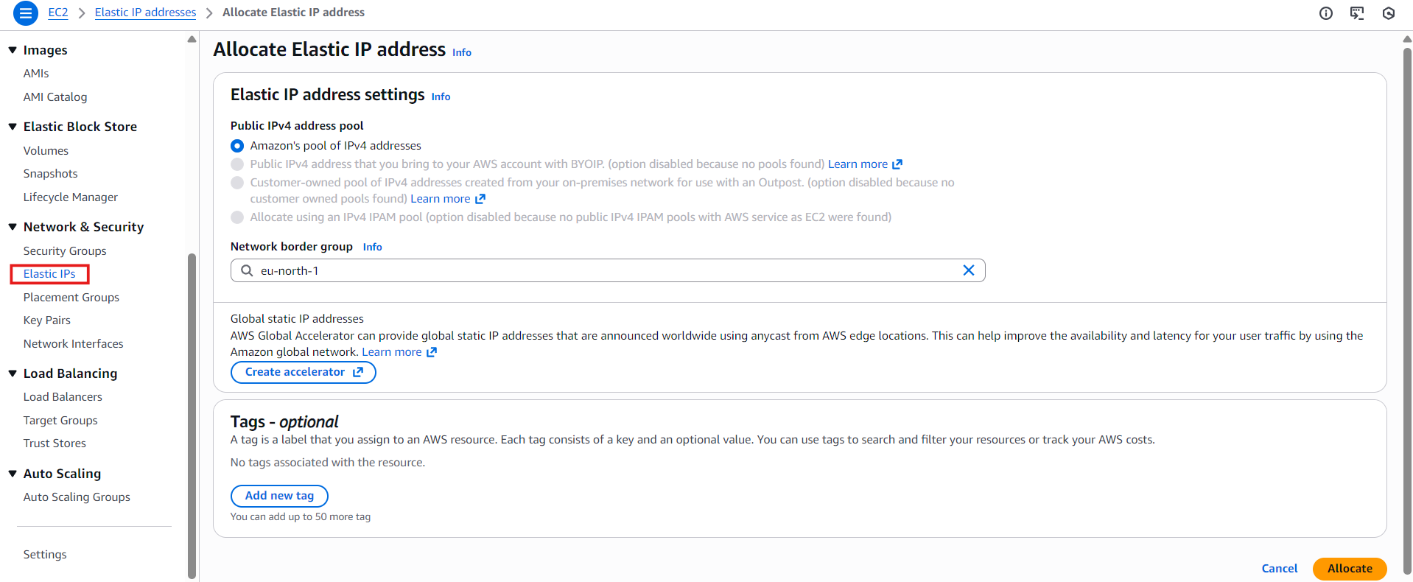

Allocating an Elastic IP
- In the EC2 console, under Network & Security, I selected Elastic IPs.
- Then I clicked Allocate Elastic IP address.
- I confirmed the correct border group (this ensures the IP is allocated in the right AWS network location).
- Finally, I selected Amazon’s IPv4 address pool and allocated the IP.
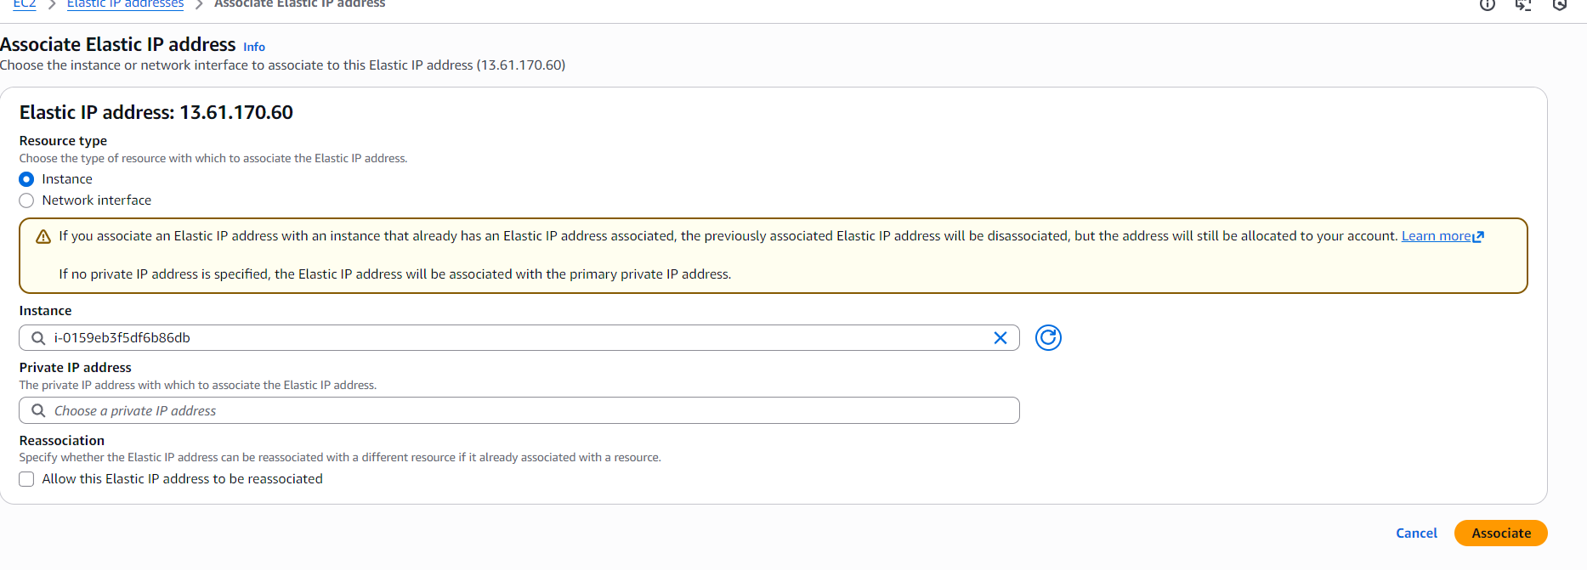

Associating the Elastic IP
- After allocating the Elastic IP, the next step was to associate it with the EC2 instance I wanted to connect to.
- I selected the Elastic IP from the list and clicked Actions → Associate Elastic IP address.
- In the association window, I chose the instance My_Instance_VPC1, which was the instance that needed a public, static IP for connection.
- I confirmed the settings and completed the association.
- Once associated, My_Instance_VPC1 instantly received the Elastic IP, making it reachable from the internet.
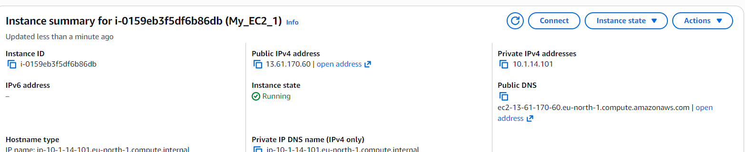

Elastic IP Successfully Assigned
- After associating the Elastic IP with My_Instance_VPC1, I checked the instance details.
- I could clearly see that the instance had now received a public IP address.
- This public IP is the Elastic IP that was assigned to me from the Amazon IP pool.
- Because it is an Elastic IP, it will remain the same even if the instance is stopped or restarted.
- With this public IP in place, the instance became fully reachable from the internet.


SSH Connection Issue
- After assigning the Elastic IP, I tried connecting to the instance again.
- This time, instead of the “no public IP” error, I ran into a new SSH error.
- The browser-based terminal couldn’t establish an SSH connection with the instance.
- This meant the issue was no longer about the public IP — it was now related to security group settings, firewall rules, or SSH ports not being open.
- So I had to troubleshoot the SSH configuration to understand what was blocking the connection.
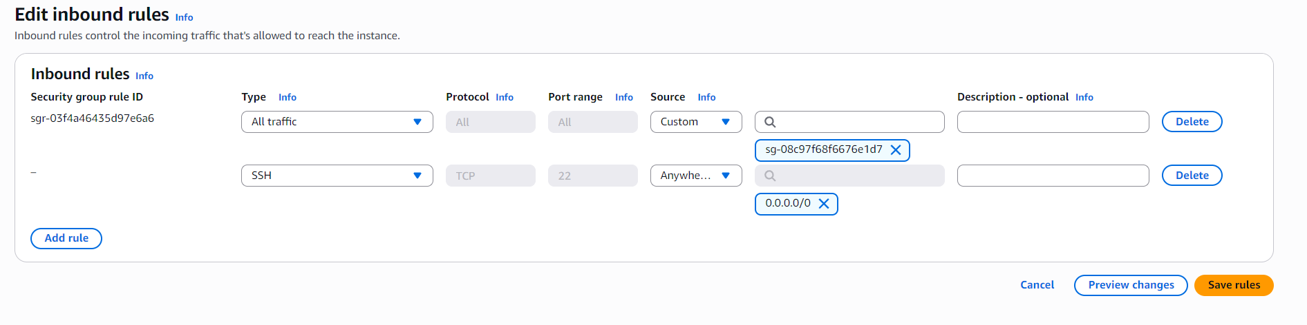

Fixing the SSH Connection Issue
- First, I checked the Network ACL, and everything looked correct.
Both inbound and outbound rules allowed the traffic that SSH needs.
- Then I checked the Security Group attached to the instance.
By default, the SG allowed all traffic only from a specific security group, not from the internet.
- Because of this, SSH (port 22) was not accessible from my public IP or from anywhere outside that SG.
- To fix it, I added a new Inbound Rule:
  - Type: SSH
  - Port: 22
  - Source: 0.0.0.0/0 (allows connection from anywhere for testing)
- After saving the rule, the instance became reachable again through SSH using the Elastic IP.
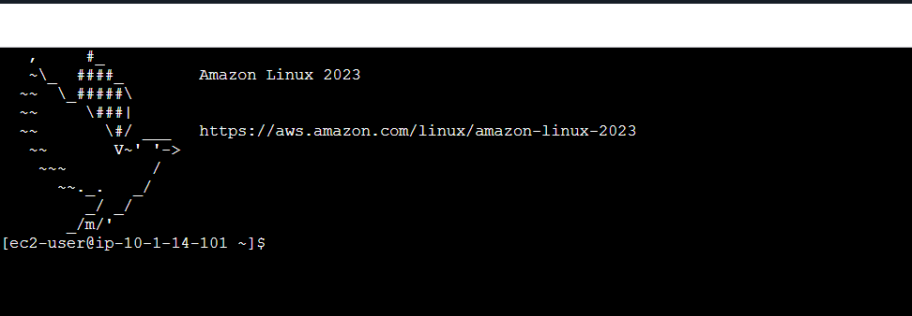

Connection Successfully Established
- After updating the security group and allowing SSH from anywhere, I retried the connection.
- This time, the SSH session opened successfully on My_EC2_1.
- The Elastic IP, route settings, NACL, and security group were now correctly configured, allowing the instance to be accessed without any issues.
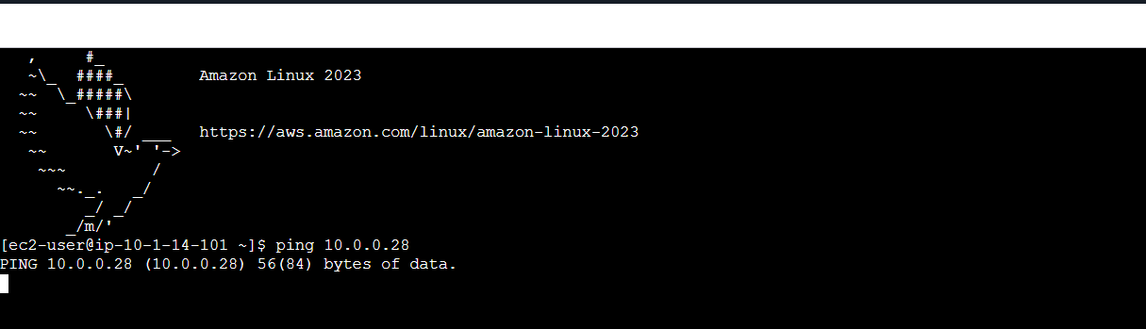

Initial VPC Peering Ping Test
- After successfully connecting to My_EC2_1, I tested cross-VPC connectivity.
- I tried to ping the private IP of the second instance (My_EC2) located in the other VPC.
- Only one ping was delivered, and then the replies stopped completely.
- This meant that although the VPC peering connection existed, something was still blocking the return traffic between the two instances.
- I had to troubleshoot the security layers (SG + NACL) to find out what was preventing full communication across the VPCs.

Fixing the ICMP Issue in the Second VPC
- After checking the setup, I discovered that the Security Group of the EC2 instance in the second VPC had no ICMP rules at all.
- This meant the instance was not allowing ping (ICMP) traffic in or out, which explained why only one ping was delivered and no replies were sent back.
- To fix this, I added a new Inbound Rule:
  - Type: ICMP – IPv4
  - Source: 10.1.0.0/16 (the CIDR block of VPC1)
- This ensured that only traffic coming from the first VPC was allowed, keeping the setup secure while still enabling cross-VPC communication.
- After saving the changes, the instance in the second VPC was now able to receive and respond to ICMP traffic from the first VPC.
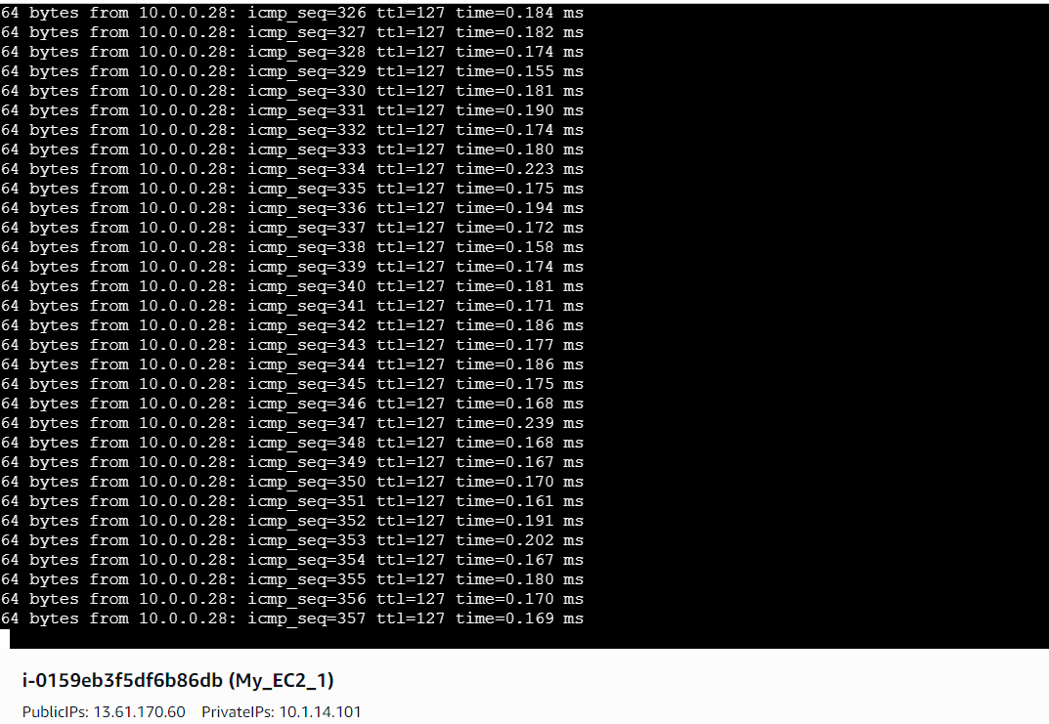

Successful VPC Peering Connectivity
- After updating the Security Group in the second VPC to allow ICMP traffic from 10.1.0.0/16, I tested the ping again from My_EC2_1.
- This time, the ping replies started coming through continuously without stopping.
- This confirmed that the instances in both VPCs were now able to communicate privately using the VPC peering connection.
- With this, the cross-VPC connectivity was successfully established and verified.

Conclusion
This project helped me understand how to design and troubleshoot communication between multiple VPCs using VPC Peering. I learned how to set up two isolated VPCs, connect them through a private peering link, configure routing paths, and adjust security layers like NACLs and Security Groups to allow cross-VPC traffic.
By launching EC2 instances in each VPC and testing connectivity with private IPs, I saw first-hand how traffic flows through the peering connection and how AWS keeps this communication entirely private, without using the public internet.
Overall, this project strengthened my understanding of:
- Multi-VPC architectures
- Route table configuration for private paths
- Security controls that affect cross-VPC traffic
- Troubleshooting network issues across isolated environments
This hands-on experience gave me a deeper understanding of how real-world cloud networks communicate securely inside AWS.

